**WEB TECHNOLOGIES**

**PLACEMENT AND TRAINING MANAGEMENT SYSTEM**

**UNDER THE GUIDANCE OF**

**MR.P.RAVINDAR RAO**

**SUBMITTED BY**

* **A.SAI KIRAN REDDY (21EG505802)**
* **D.LAXMI PRASANNA (21EG505817)**
* **G.SHIVA SAI BALAJI (21EG505826)**
* **J.HARI KRISHNA (21EG505830)**
* **K.RAHUL (21EG505835)**

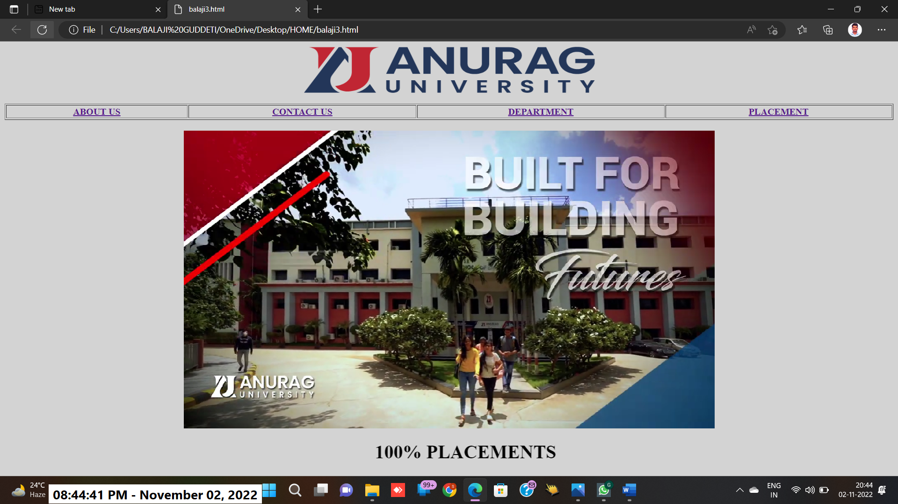

**Homepage.html**

<html>

<Body bgcolor="lightgray">

<center>

<img src="img1.png"width="500"height="80">

</center>

<br>

<table width="100%" border="1"><tr>

<th><a href="aboutus.html">ABOUT US</a></th>

<th><a href="contactus.html">CONTACT US</a></th>

<th><a href="department.html">DEPARTMENT</a></th>

<th><a href="WEB1.html">PLACEMENT</a></th>

</TABLE>

<BR>

<video width="100%" height="70%"  autoplay loop muted plays-inline class="black-video" >

<source src="vid.mp4" type="video/mp4">

<source src="vid.ogg" type="video/ogg">

 </video>

<BR>

<H1>

<MARQUEE BEHAVIOR="SCROLL" BGCOLOR="" HEIGHT="40" LOOP="10"> 100% PLACEMENTS</MARGUEE>

</H1>

</html>

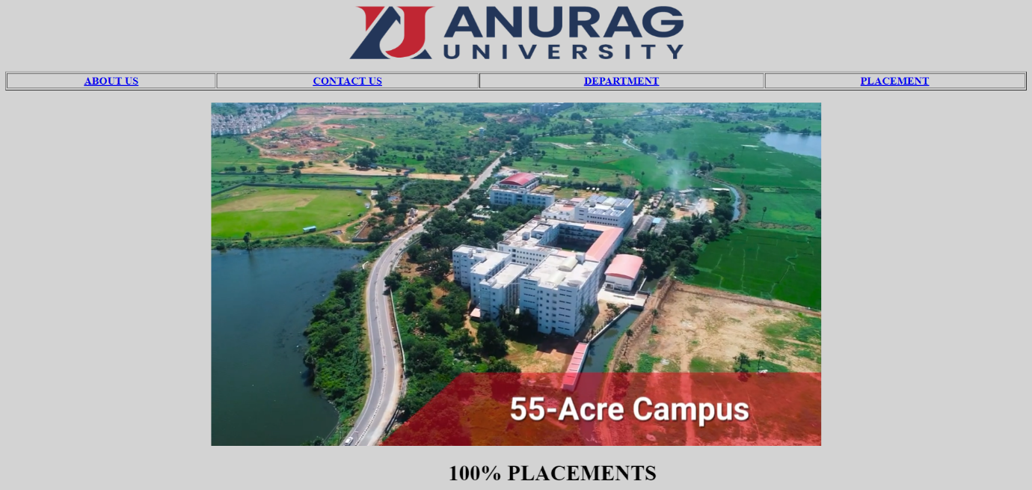

<html>

    <head>

    <title>ABOUT US</title>

    </head>

    <body bgcolor="olive">

    <h1>

    <font color="white">

    ABOUT US</font>

    </h1>

    <h2>

    Anurag University is established as a Private State University through Ordinance No. 1/2020, dated: 20.05.2020 as per the Telangana State Private Universities Act No. 11 of 2018.

    Our primary focus is to provide a high quality education in Undergraduate, Postgraduate and Doctoral programs of various disciplines.

    </h2>

    <BR>

    <H2>

    <a href="BOARD.PNG"><I>BOARD OF MANAGEMENT</I>

    </a>

    </body>

    </html>



<html>

    <head>

        <title>

            College Department Details

        </title>

    </head>

    <body bgcolor="tan">

        <h1 align="center" style="color: black;">ANURAG UNIVERSITY</h1>

        <h2 align="center" style="color: black;">Venkatapur,Ghatkesar,Hyderabad,Medchal district,pin:500088</h2>

         </p>

        <h1><i>Courses Offered</i></h1>

<h2>

        <ul>

<li>

        <a href="https://anurag.edu.in/computer_science_and/the-department/" target="display">Computer Science engineering</a>

        </li>

<li>

        <a href="https://anurag.edu.in/ece/the-department/" target="display">Electronics and communication engineering</a>

        </li>

<li>

<a href="https://anurag.edu.in/eee/the-department/" target="display">Electrical And Electronics engineering</a>

        </li>

<li>

<a href="https://anurag.edu.in/me/the-department/" target="display">Mechanical engineering</a>

        </li>

<li>

<a href="https://anurag.edu.in/civil-engineering/the-department/" target="display">Civil engineering</a>

        </li>

            </ul>

</h2>

          <h1><i><u>SCHOOL OF ENGINEERING</u></i></h1>

<br>

<h1>

Anurag University has organized to have several schools of study. The School of Engineering offers various Undergraduate, Postgraduate and Ph. D programs. The School has been ranked by NIRF and other ranking agencies. The best-in class infrastructure and Subject Matter Experts of the school will drive for the success of students.

        </h1>

    </body>

</html>



<html>

    <frameset  rows="13%,32%,45%,10%" border="0">

    <frame src="IMG.html" name="balaji">

    <frame src="MIDDLE.html" name="balaji">

    <frame src="ff.html" name="e">

    <frame src="TP.html" name="w">

    </frameset>

    </html>

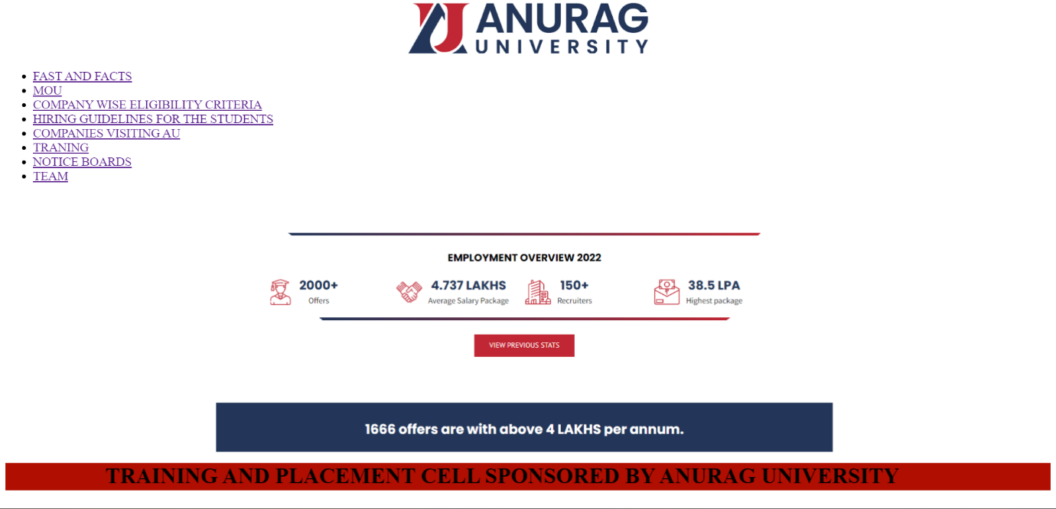

<html>

    <head>

        <title>

            Target Frames

        </title>

    </head>

    <body>

<FONT SIZE="20">

<Ul>

<li>

        <a href="PLACEMENT2022.html" target="display">PLACEMENTS 2022</a>

        </li>

<li>

        <a href="placement2021.html" target="display">PLACEMENTS 2021</a>

        </li>

        <li>

        <a href="placement2020.html" target="display">PLACEMENTS 2020</a>

        </li>

        <li>

        <a href="placement2019.html" target="display">PLACEMENTS 2019</a>

        </li>

        <li>

        <a href="placement2018.html" target="display">PLACEMENTS 2018</a>

        </li>

    </Ul>

<BR>

<IMG SRC="FF.PNG" ALT="SAI" WIDTH="1100" HEIGTH=""500>

</body>

</html>

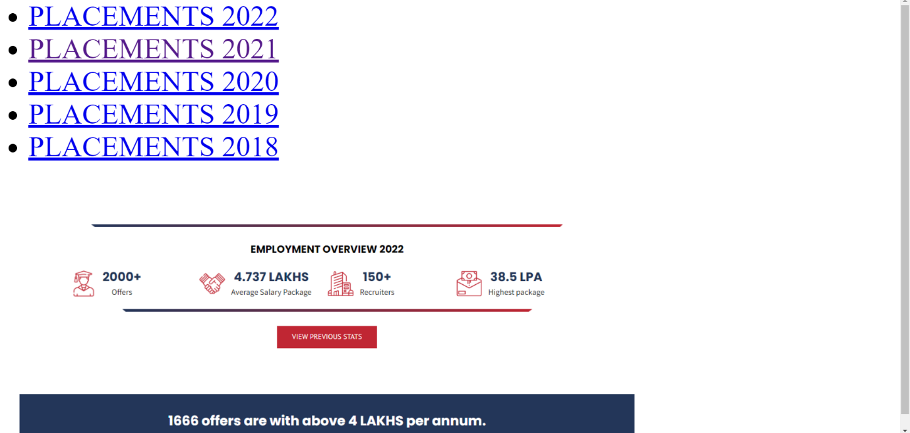

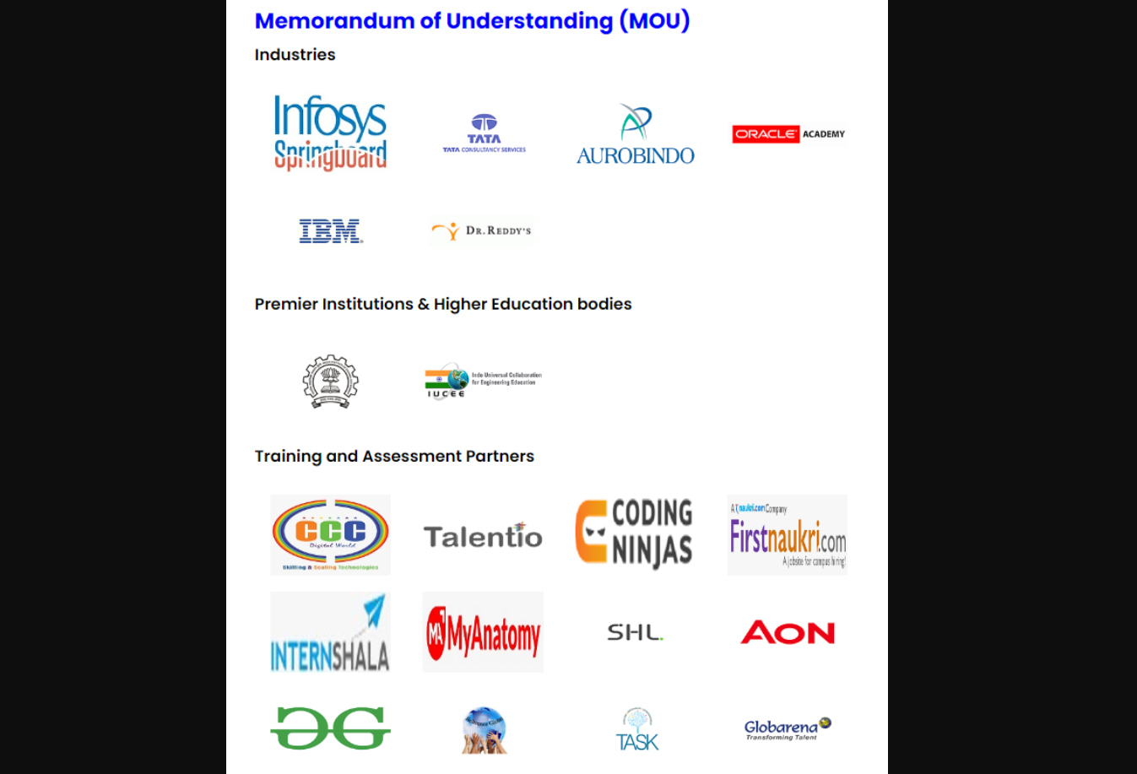

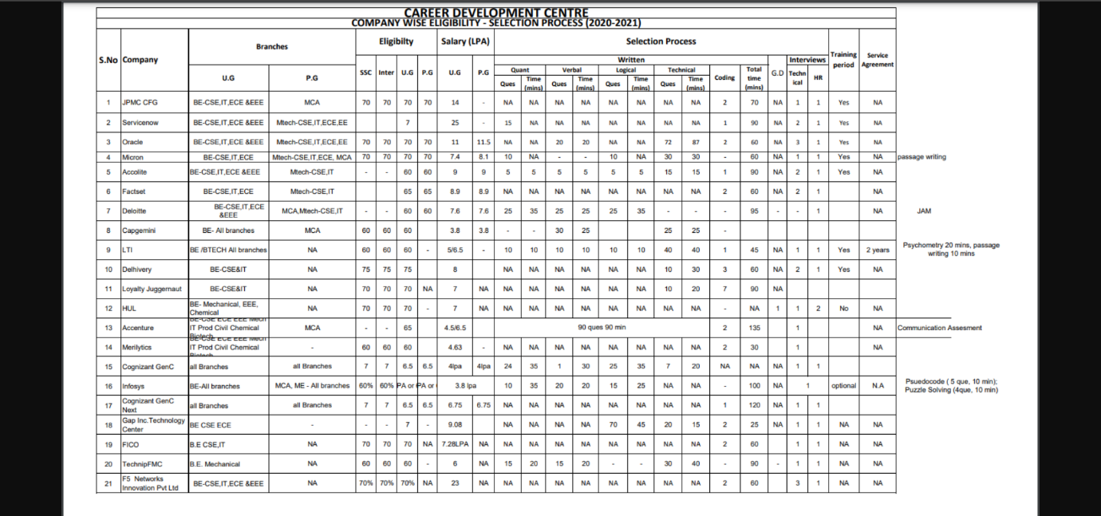

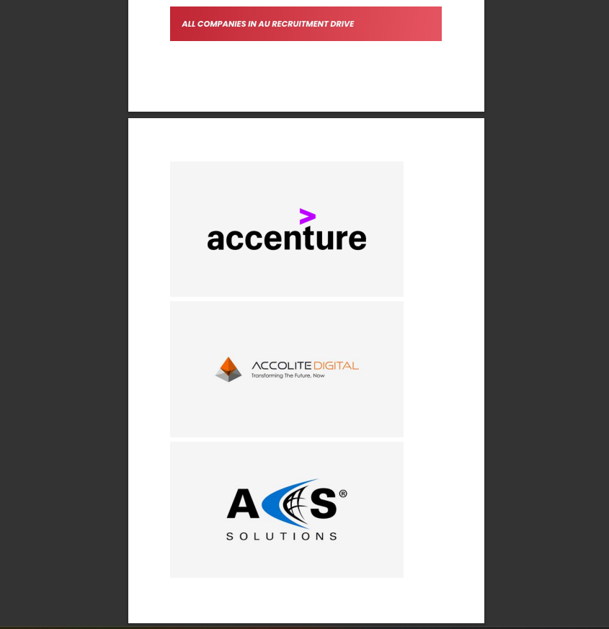

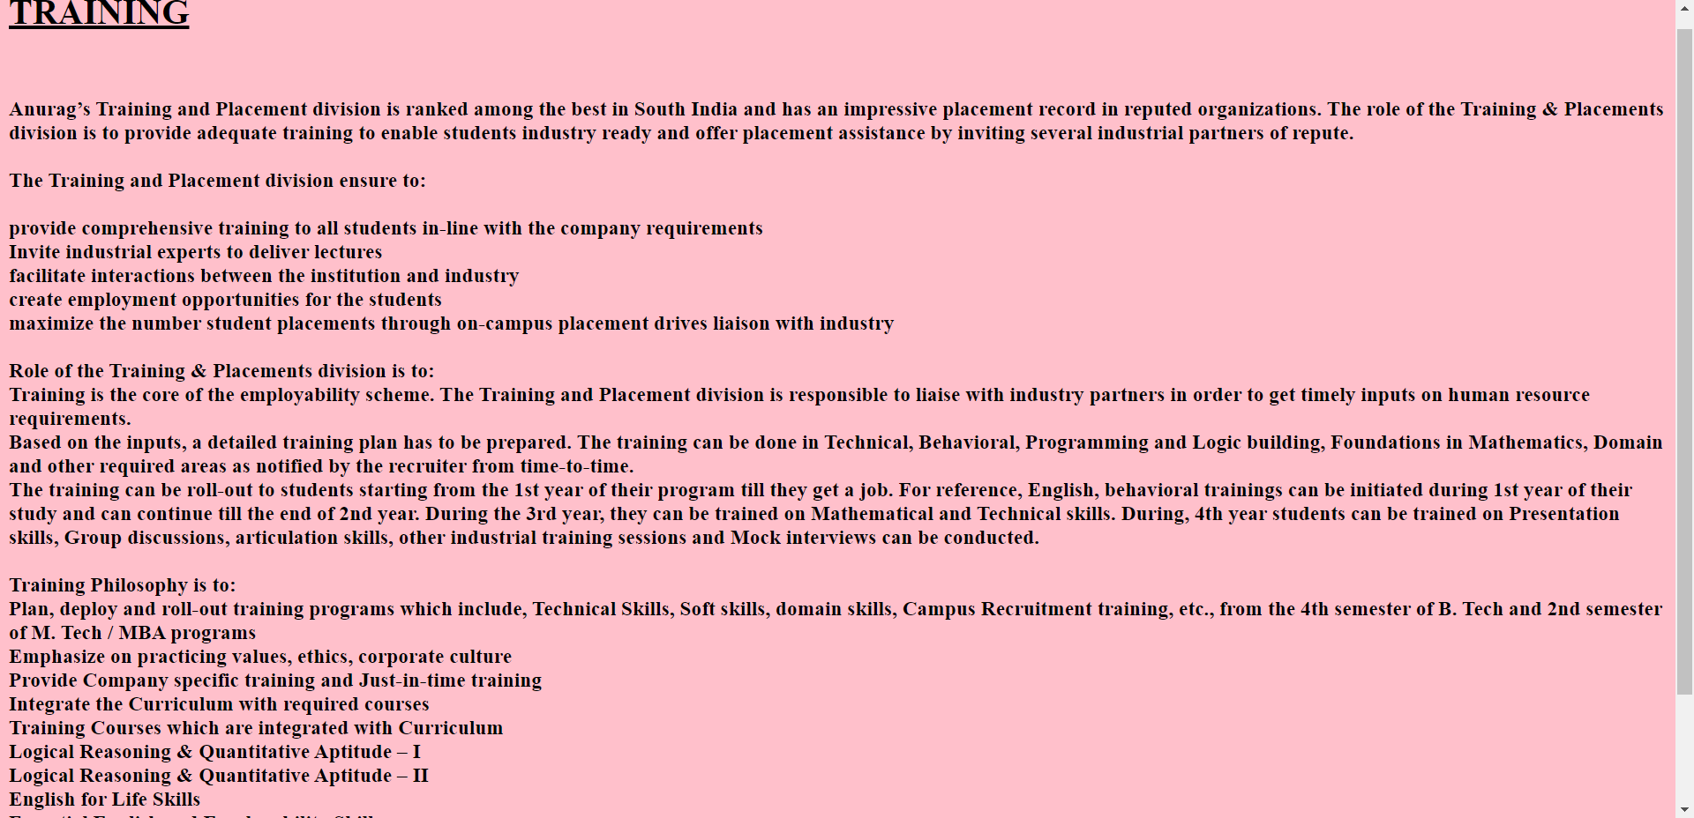

<html>

    <body BGCOLOR="SILVER">

<FONT SIZE="10">

    <Ul>

<li>

        <a href="https://www.infosys.com/" target="display">INFOSYS</a>

        </li>

<li>

        <a href="https://aws.amazon.com/" target="display">AMAZON</a>

        </li>

        <li>

        <a href="https://www.tcs.com/" target="display">TCS</a>

        </li>

        <li>

        <a href="https://www.microsoft.com/en-in" target="display">MICROSOFT</a>

        </li>

    </Ul>

</body>

</html>

